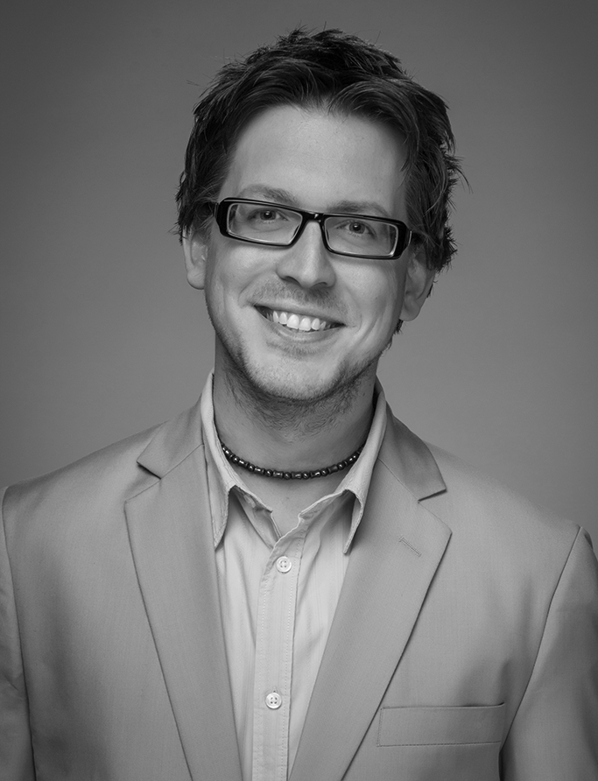

CONTACT FOR ADDRESS
Winston-Salem, NC
404-308-1089

www.danielbritt.com

danielbritt@danielbritt.com

25 Years Combined Broadcast Experience
Twenty, Radio – Five, Television

Educational, Training, & Leadership Experiences

Evergreen Baptist Christian School, Warner Robins, Georgia, K-5 - Grade 3 (1987-1991)
Lindsey Elementary School, Warner Robins, Georgia, Grade 4 - Grade 5 (1991-1993)
Tabor Middle School, Warner Robins, Georgia, Grade 6 - Grade 8 (1993-1996)
Perry High School, Perry, Georgia, Grade 9 - Grade 11 (1996-1999)
American School, Chicago, Illinois, Grade 11 - Grade 12 (1999-2000)
The Timothy Project leadership training (2014)
Liberty University, Lynchburg, Virginia, Various Credits (2015)
Certified Trainer & Facilitator, The 5 Languages of Appreciation in the Workplace (2017)

ORDAINED ELDER, First Presbyterian Church, Griffin, Georgia 2007

Broadcast Employment Experiences

PROFICIENCIES: Cool Edit Pro/Adobe Audition; Dreamweaver; Microsoft Office (Word, Excel, etc); OMT iMedia Touch; DigiLink; ENCO D.A.D.pro32; Arrakis DigiLink; Sine System; Unity4000; FrontPage; Adobe Photoshop; Natural Music; ScottStudios32; Natural Log; Music Master; Denari Online, Asana, Facebook Pages Manager

August 2016-present: i58:10 Media, Portland, OR – Fundraising Host (freelance) – Traveled to radio station clients (across the U.S.) to conduct on-air fundraising for station budgets (non-commercial stations) and for third party nonprofit organizations (such as relief organizations, rescue missions, medicinal and food providers to the poor, etc). Duties include: On-Air hosting and compelling “asks” for donations and funds, client relations, extreme flexibility, coaching, and overall “on the ground” execution of successful fundraising event.

July 2011-present: Sharing The Light Ministries, Winston-Salem, NC - Executive Producer and Co-host of the national, daily radio broadcast, “Sharing the Light with Alan Wright.” Duties include oversight of the entire radio production of the daily broadcast, supervision of other production talent and producers, content distribution to station affiliates around the country, hosting & studio coordination for monthly taping sessions.

July 2007-present: Joy FM / Positive Alternative Radio, Inc. Winston-Salem, NC / Blacksburg, VA – Vice President of Culture Integration, General Manager, & Morning Show Host. General Manager & PD over Joy FM’s 25+ stations and translators in six states. PAR VP overseeing company culture of 60 employees including corporate offices, Spirit FM, WPER, WCQR, Walk FM, and Joy FM.

April 2007-2016: Wantok Radio Light, Papua New Guinea – Produced an international version of “Daniel Britt & Friends” to air nationwide to the country’s 5+million population

April 2007-2016: Sirius XM Radio CANADA – “Daniel Britt & Friends” available via XM Canada, now making the program available via satellite to all of North America.

June 2006-June 2007: First Presbyterian Church, Griffin – “A Path Through the Bible with Tim Dalstrom” is produced by Daniel Britt and distributed to several stations for broadcast

March 2006-2016: Sirius XM Satellite Radio, New York, NY / Washington, D.C. – Host and producer of “Daniel Britt & Friends” weekly radio show on XM Channel 34, enLighten. Daniel produces a new show for each broadcast week for three separate airings. Show also simulcasts on AOL Radio, xmradio.com, and DirecTV Channel 828.

January 2004-July 2007: Life Radio Ministries, Inc., Atlanta, Georgia – Hired as Afternoon On-Air Host, Production Manager, and Administrational Assistant for WMVV-FM 90.7 NewLife.FM. Duties included hosting a five-day-a-week afternoon drive radio show from 4:30PM-7PM, producing and hosting a Southern Gospel specialty music show, “Southern Majesty” aired on Saturdays from 7PM-12AM, writing, editing, producing and overseeing production of radio spots, community announcements, underwriting acknowledgements, etc., overseeing station imaging and promos, conducting interviews, voice tracking, maintaining and designing company websites, contracting agreements with underwriting clients, worked with donor relations, processed billing and financial records for donations and accounts receivable, coordinated promotions and on-site promotional opportunities for best publicity for the station, working with Natural Music selector software and with OMT MediaTouch automation suites, among others. Remained on-air six days a week through February 2008 after full-time employment ended.

August 2003-January 2004: Salem Communications, Atlanta, Georgia—Hired as Assistant Operations Manager for WNIV-AM, WLTA-AM, and WGKA-AM, afternoon personality on WGKA, Music Director for WGKA, and Production Director for WNIV, WLTA, and WGKA. Duties ranged from training new employees, board operating, imaging two talk formats and one Gospel music format, conducting interviews, producing commercial announcements, working with ENCO D.A.D. systems, voice tracking, developing music rotations and charting, maintaining websites, voice work for sister station 104.7 The Fish (WFSH), among others. Conducted a daily afternoon drive shift from 3PM - 6PM in addition to a weekly produced specialty music show, “Gospel Classics.”

April 1999-2005: 13WMAZ-TV, Macon, Georgia/Gannett, Arlington, Virginia/CBS Television, New York, New York—started as Master Control Operator of the WMAZ Engineering Department. Duties included monitoring and controlling on-air signal, communicating with other departments, stations, networks, and CBS, working with film, videotape, and digital servers, computer knowledge included MARC II (Panasonic), affirming the completion of paid commercial time, and station premises security. Other jobs attained included Audio Director (sound mix for on-air productions/newscasts), Camera/Floor Director (coordinating on-air talent and set design; studio camera operation; studio lights), Chyron Operator (on-air graphics and fonts), TelePrompTer Operator (reading skills and dexterity). Currently on staff as a contracted Broadcast Maintenance Engineer.

July 1996 – August 2002: TOCCOA FALLS COLLEGE Radio Network—started work in 1996 with affiliates WCOP-AM, Warner Robins, Georgia and WAFI-FM, Unadilla, Georgia. Continued until December 2000 when a promotion prompted a move to Toccoa Falls, Georgia and the 100,000-watt flagship station (WRAF-FM) of the approximately 45-radio station network. Other stations listed as owned by this same company include:
WEPC-FM, Belton, South Carolina; WJYO-FM, Ft Myers, Florida; KOLX-FM, Ft Smith, Arkansas; WLET-AM, Toccoa, Georgia; WTXR-FM, Toccoa Falls, Georgia; WTFH-FM, Helen, Georgia; W230AB-FM, Gatlinburg, Tennessee plus others. Current position is morning drive-time show producer and host. Various duties in this field included on-air announcing, promotional planning, public service planning, audio editing and production, sales, interviewing, public relations, traditional office work, and Internet development.

1999-2000(annually) Georgia Baptist Convention Technical Participant/Austin Sound Design—worked under these organizations as camera operator at the yearly conventions of this Southern Baptist denomination.

2000: The Voice of the Gabby Awards for the state of Georgia (presented by the Georgia Association of Broadcasters): writing, editing, production and vocal talent for introductions and vignettes in the awards ceremony - held to honor participating radio and television stations in the state of Georgia for outstanding programming and service.

2000: WLET-AM, Toccoa, Georgia—on-air personality for Southern Gospel Radio, including a daily, locally produced Gospel Music Radio Show, “Turn Your Radio On.”

Various (Broadcasting):
- Concert and product radio commercial producer for the Bill Gaither Homecoming Concert Series, nationwide (Gaither Music, Premier Productions)
- Concert and product radio commercial producer and announcer for comedian/singer Scott Davis
- Voice production services for capital campaigns and special event promotions for Reynolda Church, Winston-Salem, NC
- Full length radio documentary production on Bill & Gloria Gaither, including hours of on-site interviews with the Gaithers in Alexandria, Indiana (2008)
- Event emcee at various events, including stage welcome of Georgia Governor Sonny Perdue (Feb. 2007)
- Announcer and voice for Saturdays with Mark [Lowry] & Tony [Campolo] (www.marklowry.tv)
- Announcer and voice for The Mark Lowry Show (www.marklowry.tv)
- Announcer and voice for Ernie Haase & Signature Sound’s Summer Spectacular 2006 concert tour for stage multimedia presentations
- Voice work for various media outlets under the ClickSpotz talent pool
- Voice work for various radio under the Fellowship of Christian Broadcasters talent pool
- Television voice work for WVGN-TV NBC, U.S. Virgin Islands
- Miscellaneous production/editing for John Young, national voice talent
- Voice work for American Family Radio Network (AFR), Mississippi
- Primary Station Imaging Voice for KCMI, Nebraska
- Primary Station Imaging Voice for NPR WVGN, U.S. Virgin Islands
- Radio On The Scene Reporting for Salem Radio Network (SRN) News, Washington, D.C., including live updates from the 2003 Montgomery, Alabama Ten Commandments Story; Larry Burkett funeral/memorial in Atlanta, GA.
- Voice work for KIJN, Farwell, Texas
- Voice work for WNNG, Warner Robins, GA
- Television Audio Talent for Public Service Announcements, Promotionals, Spots, etc for CBS Television, Macon, Georgia.
- Muscular Dystrophy Association “Jerry Lewis Labor Day TeleThon” – Voice Talent for opening introductions and productions (annually, 1999-2000)
- Raytheon, Inc – Voice production for computer tutorial program manufactured by Raytheon
- Miscellaneous voice production for radio, television, and other multimedia productions through danielbritt.com

Music Experiences

Pianist since 1989
1995-1999 Chorus Pianist for Tabor Middle School; Perry High School Chorus
1998-2001 Directed, planned/produced several ‘local’ Bill Gaither-style “Homecoming” gatherings. Promotion, coordinating, music clearance, rehearsals and technical duties involved.
  - Pianist for New Life Christian Church, Macon, Georgia
  - Performed at The Governor’s Mansion, Atlanta, Georgia-Gov. Zell Miller (with the governor and first lady of Georgia in attendance)
  - Pianist for Macon, Georgia Southern Gospel Quartet, “Gospel Call”
1999 Performed at Maranatha Baptist Church, Plains, Georgia-home church of President Jimmy Carter (with former President and first lady in attendance).
- Pianist for professional Southern Gospel Quartet, based from Jacksonville, Florida, “Canaanland Boys” (including cross country tour to the western United States)
2001 Regular backup pianist for Friendship Baptist Church, Toccoa, Georgia’s oldest black church. Directed, rehearsed with choir and musical guests.
2002 Directed/Produced Special Church Music Evening at Grace Bible Church, Mountain City, Ga. Promotion, coordinating, booking, music clearance, rehearsals and technical duties involved.
2006 Pianist at various times for First Presbyterian Church, Griffin, Georgia
Various (Music) Weddings, Special Events, Concerts, Rehearsals, Radio
Production/Jingles, Church Events & Services

References:

CONTACT FOR A LISTING danielbritt@danielbritt.com

Online Contacts:
http://www.danielbritt.com http://www.toccoafalls.edu
http://www.13wmaz.com http://www.salem.cc

http://www.wniv.com http://www.thefishatlanta.com

http://www.themighty1190.com http://www.missionaryradio.info

http://www.newlife.fm http://www.enlighten34.com

http://www.xmradio.com http://www.joyfm.org

http://www.dearchristianradio.com http://www.sharingthelight.org

http://www.i5810media.com http://www.siriusxm.com

